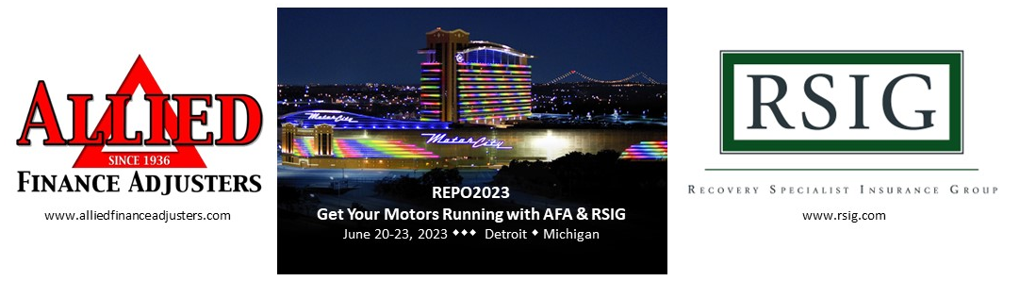
REPO23 – Post Conference Highlights
RSIG and Allied have always prided ourselves on bringing attendees industry relevant information. Our commitment to education, training and professionalism demands it and the reviews of REPO23 held last week at the Motor City Hotel and Casino in Detroit, Michigan proves it!
- Repo 2023 was a great show and it’s always wonderful to catch up with my friends and colleagues for some education and networking. – Bryanna Cox, TexasARP

- One of the largest attended educational events I have ever attended. Great presentations by Subject Matter Experts.REPO 2023 – Ron Brown, Eagle Group XX/USA

- Amazing conference So informative best one Yet! Everything was so to the point! The speakers, the content, and the food was just perfect...... – Steve Torres, CIR Enterprises

- Thank you as always, we appreciate all the hard work from both the associations – Mike Williams, Miller Industries

- Always great coming, I had a blast! – Jordan Sawalqah, Recovery Database Network/ClearPlan
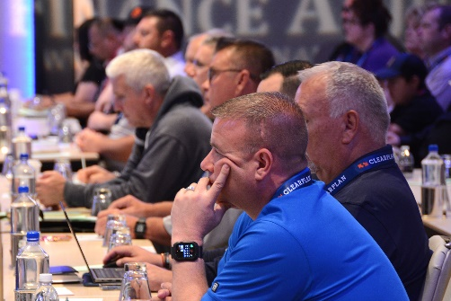
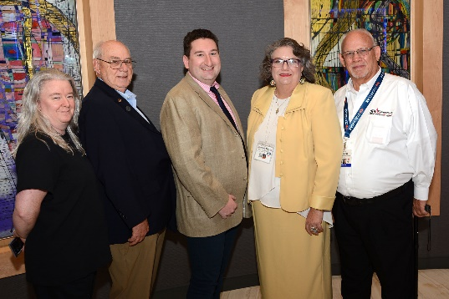
The REPO23 conference brought together a powerhouse group of speakers which included a representative from the American Financial Services Association, who spoke about how their lobbying efforts speak to the needs of the repossession industry, a dynamic presenter from Energy Security Agency who provided vital information on electric vehicles, Narcan training from the Detroit Wayne Integrated Health Network with each attendee receiving a training certificate and NARCAN kit (along with information on how to get this training in your own state), Cyber Security and additional NEW internet profiling training by Michele Stuart of JAG Investigations, a new Mindset Matters Driver training program through the National Safety Council certified instructor Leon Scroggins and of course legal updates, things to look for in contracts, case law and more from Mike Howk, RSIG’s Director of Education and Machelle Morris, attorney for Allied Finance Adjusters.
There were door prize winners, award winners and a winner of his choice of either a Dynamic Slide In unit or a Dynamic Fork Lift attachment to benefit the Recovery Agents Benefit Fund. Through generous contributions from American Recovery Services, Credit Acceptance Corporation, Dynamic Towing Equipment and Mfg. and others, and the support of REPO23 attendees in the live fundraising auction, the RABF received more than $54,000 in event sponsorship and donations in order to further their goal of assisting repossessors in their times of need.
It is often said that these events can be held virtually and are only a requirement of insurance providers for continuing education; but that is simply not true. In-person networking events have gone on for years in this industry and RSIG’s meetings primary focus has always been education and training with Allied sharing similar views; but continuing education came about from a requirement of the clients in the industry who see the reason and value behind it.
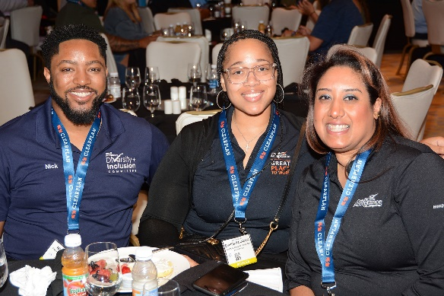
Can you get your education and training online? – certainly. Is it the same quality and does it offer the same energy as in person? – no; and the energy and buzz after each REPO23 training session, meal and social function proves the value of in-person events. So plan on joining us next year at REPO2024, the week of June 16th, more information is coming soon!
